Spearman rank correlation: AUDUSD and USDCHF
Method 02 / daily log returns / Alpari D1 full available history

Study setup
Logical pair: AUDUSD , USDCHF
Broker symbols: AUDUSD_i , USDCHF_i
Snapshot: 2026-11-03_majors_alpari_D1
Timeframe: D1
Matched return window: 1999-01-05 to 2026-11-02 (UTC bar dates)
Matched return count n: 7200
Dropped unfinished last bar dated 2026-11-03 UTC after a tick-volume check against the prior complete day.
Complete matched rows (CSV): AUDUSD-USDCHF_Spearman_D1.csv
Complete matched rows (HTML table): AUDUSD-USDCHF_Spearman_D1_data.html

Method carried forward
Spearman rho is Pearson correlation on the ranks of matched daily log returns of close, ln(close_t / close_t-1), in the broker quote direction. Ties use average ranks. Quotes are not inverted. rho is symmetric under swap of the two symbols. rho = 0 means no consistent rank-order link in this sample; it does not mean no link of any kind. The score is not a cause, not a lead, and not a trading signal. Daily rows are not independent draws, so the two-sided p-value and approximate Fisher interval are reported and treated as secondary to rho. Same-sample Pearson r is shown only as a side check; a large rho minus r gap can flag outliers or a non-straight link.

Results
Spearman rho: -0.442076
Two-sided p-value: 0
Approximate 95% Fisher interval: [-0.460473, -0.423299]
Same-sample Pearson r: -0.380878
rho minus r: -0.061197

Conclusion
Over 7200 matched daily log-return rows for AUDUSD and USDCHF (broker quote directions unchanged), Spearman rho is -0.4421 (negative, moderate rank-order association in this sample). Approximate 95% Fisher interval: [-0.4605, -0.4233]. Same-sample Pearson r is -0.3809 (rho minus r = -0.0612). Two-sided p under the usual independent-ranks model is 0; that model does not match linked daily FX returns, so treat p as secondary. This does not establish cause, lead-lag, or a lasting trading rule.

Charts
Daily closes

Daily log returns
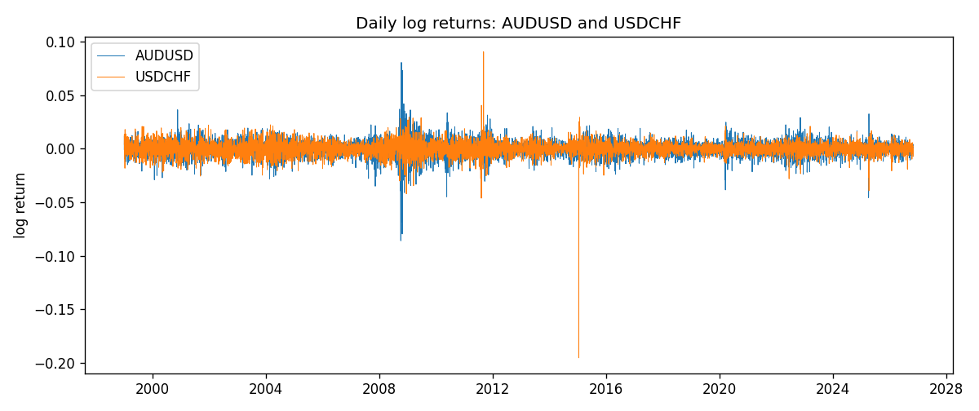
Log-return scatter
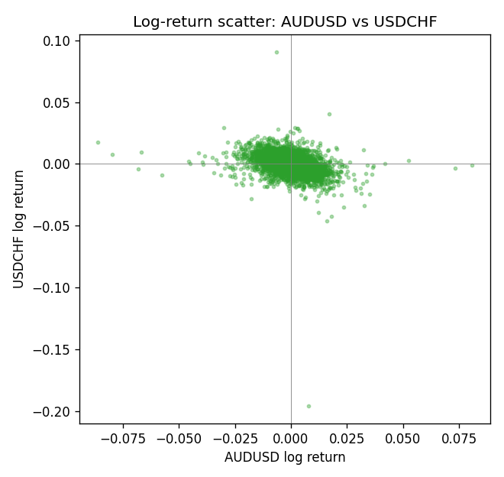
Rank-rank scatter
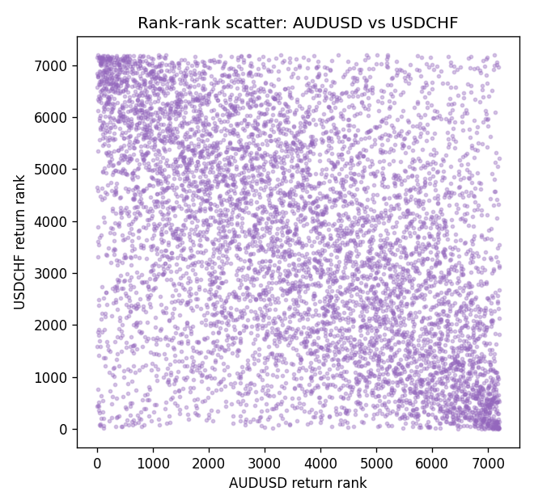

Data report
Every matched row that entered Spearman rho is stored in the sibling CSV named AUDUSD-USDCHF_Spearman_D1.csv. That file is the complete data archive for redrawing charts. Embedding all rows as a Word table is impractical at this length; the Word file holds the column list, column summaries, and the first and last 15 matched rows.
Columns: time, AUDUSD_open, USDCHF_open, AUDUSD_high, USDCHF_high, AUDUSD_low, USDCHF_low, AUDUSD_close, USDCHF_close, AUDUSD_tick_volume, USDCHF_tick_volume, AUDUSD_spread, USDCHF_spread, AUDUSD_real_volume, USDCHF_real_volume, AUDUSD_log_return, USDCHF_log_return
Column summaries (matched calculation rows)
column | count | mean | std | min | 25% | 50% | 75% | max
AUDUSD_open | 7200 | 0.7519587 | 0.13528421 | 0.4785 | 0.6610975 | 0.731415 | 0.8091275 | 1.10284
USDCHF_open | 7200 | 1.0982244 | 0.25258622 | 0.72022 | 0.920675 | 0.990175 | 1.238625 | 1.8219
AUDUSD_high | 7200 | 0.75601148 | 0.13584385 | 0.4878 | 0.6647 | 0.734785 | 0.8152525 | 1.10795
USDCHF_high | 7200 | 1.1035234 | 0.25433538 | 0.73305 | 0.9249475 | 0.99377 | 1.2436 | 1.8313
AUDUSD_low | 7200 | 0.74790307 | 0.1345988 | 0.4775 | 0.65778 | 0.727495 | 0.804225 | 1.0975
USDCHF_low | 7200 | 1.0930985 | 0.25099871 | 0.08565 | 0.917415 | 0.98668 | 1.232725 | 1.8121
AUDUSD_close | 7200 | 0.75201172 | 0.13526687 | 0.4786 | 0.6612 | 0.731695 | 0.8091975 | 1.10169
USDCHF_close | 7200 | 1.0982149 | 0.25248642 | 0.72025 | 0.92097 | 0.990145 | 1.238625 | 1.8217
AUDUSD_tick_volume | 7200 | 77358.386 | 138142.18 | 109 | 5440 | 43334.5 | 71332.25 | 1234623
USDCHF_tick_volume | 7200 | 74199.562 | 113414.45 | 350 | 12776 | 40195 | 70261.25 | 858589
AUDUSD_spread | 7200 | 30.817222 | 16.887144 | 0 | 13 | 30 | 50 | 50
USDCHF_spread | 7200 | 26.104306 | 24.710129 | 0 | 5 | 16 | 50 | 100
AUDUSD_real_volume | 7200 | 5.2428187e+09 | 1.2538918e+11 | 0 | 0 | 0 | 0 | 3.811512e+12
USDCHF_real_volume | 7200 | 2.3239785e+10 | 8.9047261e+10 | 0 | 0 | 0 | 0 | 1.9331921e+12
AUDUSD_log_return | 7200 | 2.837e-05 | 0.00754598 | -0.08602525 | -0.00385535 | 0.0002835 | 0.00415437 | 0.0806166
USDCHF_log_return | 7200 | -7.168e-05 | 0.00659376 | -0.19545699 | -0.00336083 | 8.057e-05 | 0.00331954 | 0.09051364
First 15 matched rows (selected columns)
time | AUDUSD_close | USDCHF_close | AUDUSD_log_return | USDCHF_log_return | AUDUSD_tick_volume | USDCHF_tick_volume
1999-01-05 | 0.6215 | 1.3724 | -0.00080418179 | 0.0039424743 | 1103 | 4666
1999-01-06 | 0.6289 | 1.3912 | 0.011836351 | 0.013605652 | 1412 | 3740
1999-01-07 | 0.6345 | 1.3782 | 0.0088650256 | -0.0093883841 | 1468 | 4262
1999-01-08 | 0.6347 | 1.3935 | 0.00031515916 | 0.011040268 | 1225 | 5991
1999-01-11 | 0.6393 | 1.4009 | 0.0072213815 | 0.0052963193 | 1318 | 5236
1999-01-12 | 0.6362 | 1.3872 | -0.0048608485 | -0.0098275602 | 1908 | 5975
1999-01-13 | 0.6312 | 1.3621 | -0.0078902098 | -0.018259701 | 1829 | 7036
1999-01-14 | 0.6295 | 1.3588 | -0.002696916 | -0.0024256692 | 1593 | 5825
1999-01-15 | 0.634 | 1.3834 | 0.007123101 | 0.01794228 | 1604 | 7434
1999-01-18 | 0.6346 | 1.379 | 0.00094592471 | -0.0031856384 | 1430 | 4965
1999-01-19 | 0.6392 | 1.3789 | 0.0072225153 | -7.2518946e-05 | 1733 | 5494
1999-01-20 | 0.64 | 1.3889 | 0.0012507819 | 0.0072259871 | 1901 | 5477
1999-01-21 | 0.6405 | 1.3836 | 0.00078094498 | -0.0038232689 | 1946 | 4736
1999-01-22 | 0.6327 | 1.3834 | -0.012252745 | -0.0001445609 | 1875 | 4833
1999-01-25 | 0.6302 | 1.3868 | -0.0039591468 | 0.0024546976 | 1413 | 3996
Last 15 matched rows (selected columns)
time | AUDUSD_close | USDCHF_close | AUDUSD_log_return | USDCHF_log_return | AUDUSD_tick_volume | USDCHF_tick_volume
2026-10-13 | 0.69821 | 0.83244 | 0.0035007712 | -0.0024955621 | 34335 | 32763
2026-10-14 | 0.69715 | 0.83489 | -0.0015193215 | 0.0029388325 | 43650 | 40903
2026-10-15 | 0.69191 | 0.82676 | -0.0075447063 | -0.0097855323 | 50656 | 54132
2026-10-16 | 0.69426 | 0.82377 | 0.0033906408 | -0.0036230826 | 40991 | 47176
2026-10-19 | 0.6978 | 0.82677 | 0.0050859986 | 0.0036351779 | 37273 | 40610
2026-10-20 | 0.70022 | 0.8246 | 0.0034620426 | -0.0026281224 | 38736 | 42106
2026-10-21 | 0.70275 | 0.82427 | 0.0036066384 | -0.00040027413 | 36307 | 37648
2026-10-22 | 0.70186 | 0.82032 | -0.0012672558 | -0.0048036381 | 43496 | 50809
2026-10-23 | 0.70353 | 0.82497 | 0.0023765656 | 0.005652514 | 39675 | 45872
2026-10-26 | 0.70128 | 0.82649 | -0.0032032829 | 0.0018407959 | 35142 | 41336
2026-10-27 | 0.70245 | 0.82865 | 0.0016669876 | 0.0026100526 | 34625 | 35560
2026-10-28 | 0.70533 | 0.82781 | 0.0040915541 | -0.0010142111 | 46279 | 42431
2026-10-29 | 0.70245 | 0.82379 | -0.0040915541 | -0.0048680164 | 45705 | 53780
2026-10-30 | 0.70316 | 0.82438 | 0.0010102376 | 0.00071594559 | 42925 | 55459
2026-11-02 | 0.69971 | 0.81851 | -0.0049184984 | -0.0071459744 | 41137 | 45329

